

Direct Vendor Ordering V3.1.0

Overview

Version 0.5
January 17, 2006

Table of Contents

Revision History 2
Definitions 2
Introduction 2
Creating orders on the Handheld 2
DVO Website 2
dvo.wholefoods.com 2

Revision History

Revision | Date | Author | Notes
0.1 | 11/14/03 | Paul Gingrich | Initial version
0.2 | 11/17/03 | Paul Gingrich | Next steps
0.3 | 1/9/04 | Ian Steyaert | Updates for V1.0
0.4 | 4/20/05 | Sam Gordon | Updates for V2.1.0
0.5 | 1/17/06 | Ramona Maher | Updates for V3.1.0

Definitions

DVO – Direct Vendor Ordering system

FTP – File Transport Protocol

VIM-Vendor Item Master

Introduction

The purpose of this document is to describe the Direct Vendor Ordering system developed by the WFM Central Support Store Ordering Systems team.

A Specialist/Buyer creates orders by scanning products with a handheld device. The device is then docked and synched to a website where the system loads the order into a database. The Specialist/Buyer can then review the orders via the website. Finally the Specialist/Buyer submits the orders and they are transmitted to the appropriate vendors via fax, email and direct file transmission.

The system provides an extranet where vendors can “acknowledge” that orders have been received. The vendors are able to enter optional shipping and out-of-stock information. WFM Specialist/Buyers can review the status of their orders, seeing whether or not vendors have received their orders.

The system provides administrative access for monitoring background processes and order transmission, updating users and vendors and generating reports.

History

The business reasons for developing DVO included:
- Removing the dependency from 3rd party vendors, specifically OrderDog. This provides for better information security, since item and supplier information are housed internally. The ability to work directly with our suppliers affords Whole Foods the opportunity to eliminate 3rd party cost and pass that savings to the customers.
- An additional business need was the desire to create a more intimate relationship with suppliers by implementing electronic B2B (i.e. Business to Business) communications. This improves the overall reliability of the ordering process and makes it easier to eventually implement eInvoicing.
- Lastly, building an ordering system internally has enabled us to tailor it to WFM needs.

DVO was developed in the fall of 2002 as an Alpha system and went Beta in early 2003. DVO was designated as a production system after the Beta 3.1 release and as of January 2006 is now at release V3.1.0.

Creating orders on the Handheld

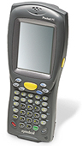
The specialist uses a handheld to create orders (a list of acceptable handheld devices located on DVO website in ‘User Help Guide’ under ‘Handheld Info’). The handheld is similar to a PocketPC except that it has UPC scanning capabilities.

The specialist walks the aisles, scans a UPC barcode and enters a quantity. The screen on the handheld (shown at left) allows the specialist to see the list of items they have scanned as well as edit items already scanned.

After completing the order, the specialist docks the handheld in a cradle attached to their PC and synchs the order with the DVO website.

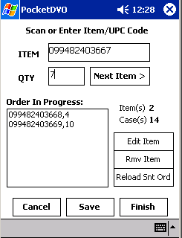

During the synch and order loading process the system will match UPC codes against the items in the regional merchandising system, looking to ensure that the store is authorized to order the item as well as confirming the primary vendor for the item. In fact, the system doesn’t access the regional merchandising system directly, but goes through another database that rolls up all of the item data for all the regions. This database is called VIM, for Virtual Item Master and is managed by Central Support.

The Specialist/Buyer then proceeds to login to the DVO website to review their orders and add any additional items, such as special orders.

DVO Website

Ready Order List
The Specialist/Buyer logs in to the DVO website to review their orders. The system will have automatically created a separate purchase order for each of the vendors whose products were scanned.

In the example below, the last order loaded into DVO was for Aloe Life. The Specialist/Buyer also has the option to create an order directly from the web site as well.

The Specialist/Buyer can review an individual order by double-clicking on the order number to view the order details.

Order Details

From the order details, the Specialist/Buyer can remove items, update items or reassign items to different vendors.

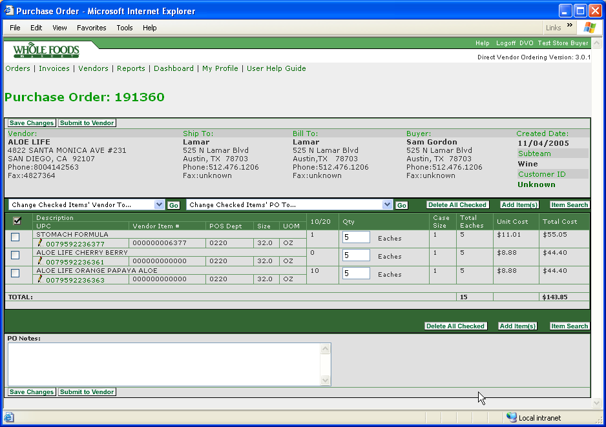

By clicking on the UPC code, the Specialist/Buyer can update individual item details.

Item Details

From the item details screen, the Specialist/Buyer can update cost or other information.

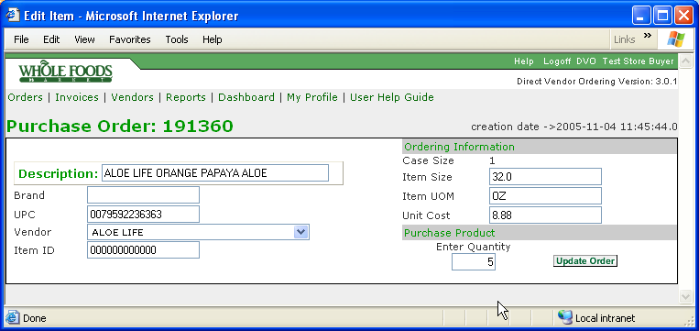

Add Item(s)

The Specialist/Buyer can add special orders by vendor item number or by UPC. Do not type text/words into the Add Items box. Only UPC and Vendor Item Number values are acceptable. Separate each new UPC/VIN by a new line (not a comma) as the example suggests.

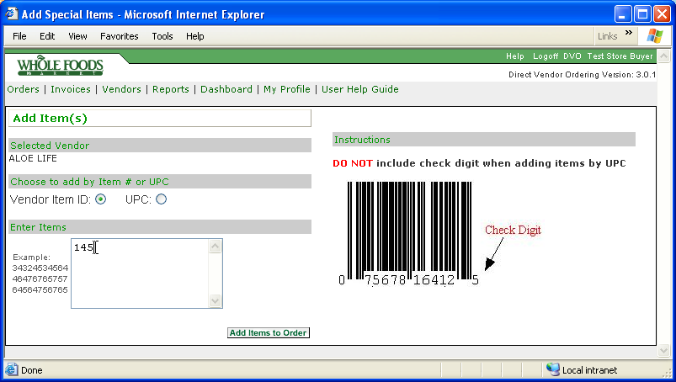

Search

The Specialist/Buyer can search for items using the search tools. Only items that are currently maintained in the Regional Hosting System will be available through Search.

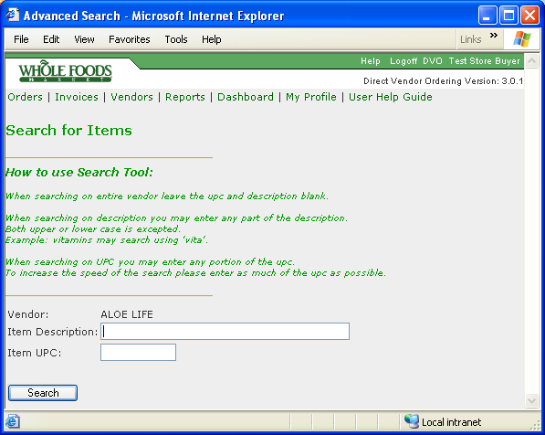

Handling scan errors

Even if a scanned item is not authorized for the store, the Specialist/Buyer can assign the item to a particular order. The Specialist/Buyer is also asked to report scan errors to the store scan coordinator so that the item can be updated in the regional merchandising system.

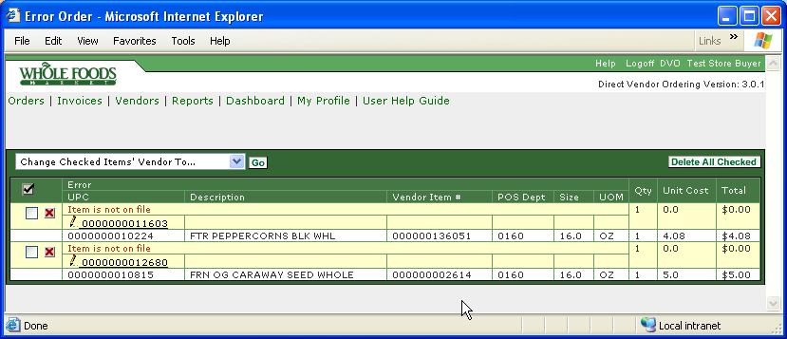

Submitting the order

After reviewing and making any changes, the Specialist/Buyer submits their orders to the vendors. Once the Specialist/Buyer enters “submit”, the DVO system automatically faxes, emails or directly transmits the orders. After a short period of time, the Specialist/Buyer is then able to review the status of their orders from the “sent” list page.

Sent orders may have any one of a number of statuses
- Sent – the order has been successfully transmitted to the vendor
- Unacknowledged – the order has been sent, but the vendor has not yet acknowledged receiving the order
- Acknowledged – the order has been sent and the vendor has acknowledged the order

Once an order is received by the vendor, the Specialist/Buyer can close the order.

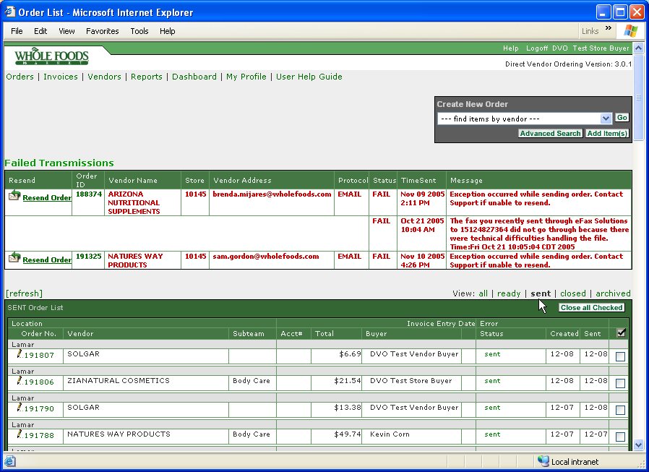

Administration

DVO provides a page where an individual can update their profile information, including changing their password

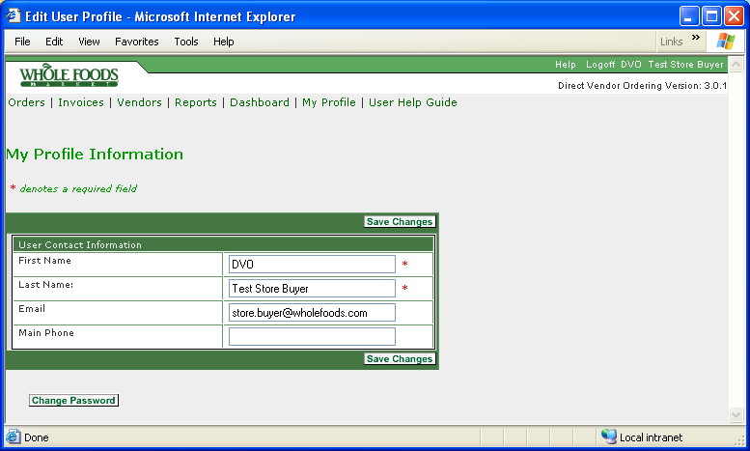

The Specialist/Buyer can also view all the vendors supported by DVO and vendor profile information including the order transmission method.

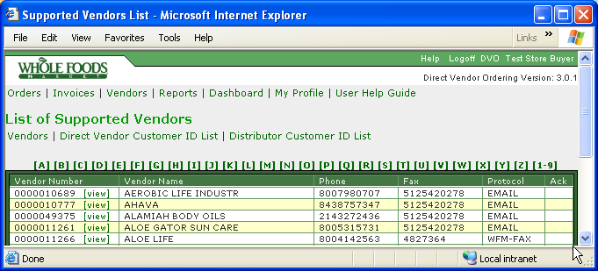

DVO supports a superuser administration area where administrators can:
- Add vendors and update vendor information
- Add users and update user information
- Monitor job processes
- Monitor order transmissions
- Resend orders that failed during transmission
- View log files
- Run reports

dvo.wholefoods.com

Vendors are able to access the DVO site in order to review and acknowledge orders sent to them. This is the view that a vendor will see.

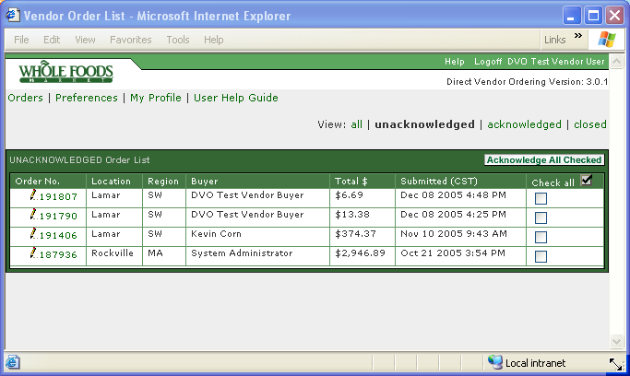

In the screen snap below, a vendor has acknowledged an order and has entered shipping information. This shipping information is available for the Specialist/Buyer to view from their pages.

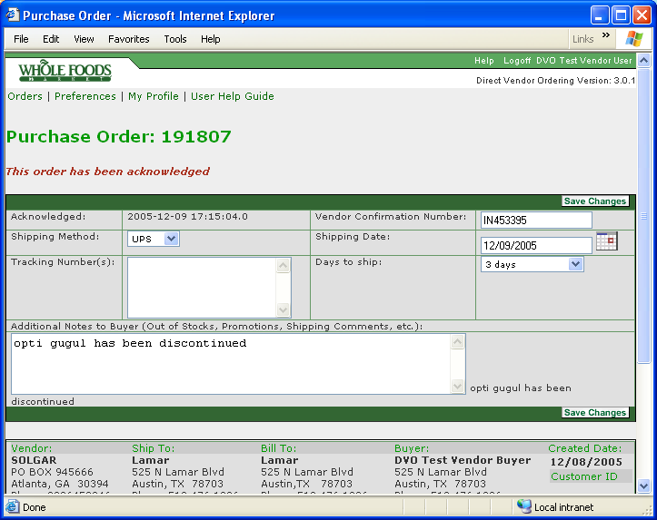

The dvo.wholefoods.com site also has pages where a vendor can update their contact information and can enter customer account numbers for each of the stores that use DVO.

